**Monitoring Task**

**Task Description:**

**Install Prometheus and Grafana on a Linux EC2 machine, connect Prometheus to Grafana, and create a dashboard to view metrics.**

Explanation:

1. Launch 2 EC2 Instances, one- Prometheus, another – node_exporter

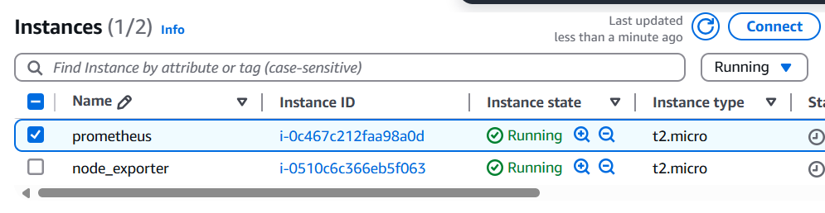

1. Connect the prometheus using putty, copy the ipv4 address

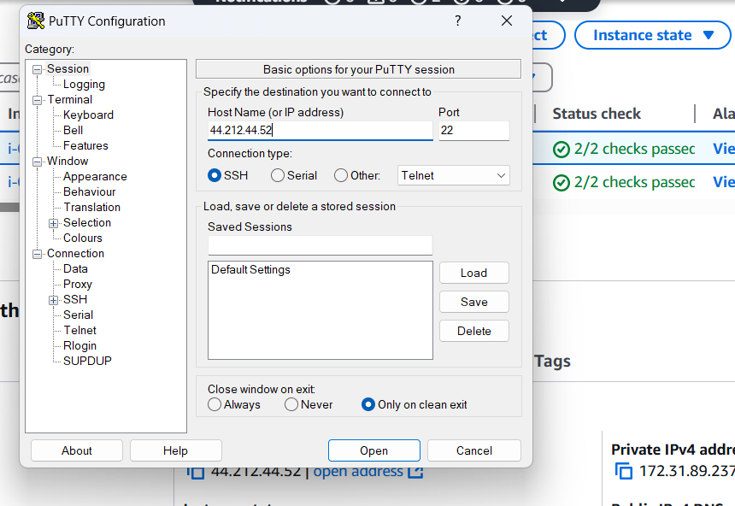

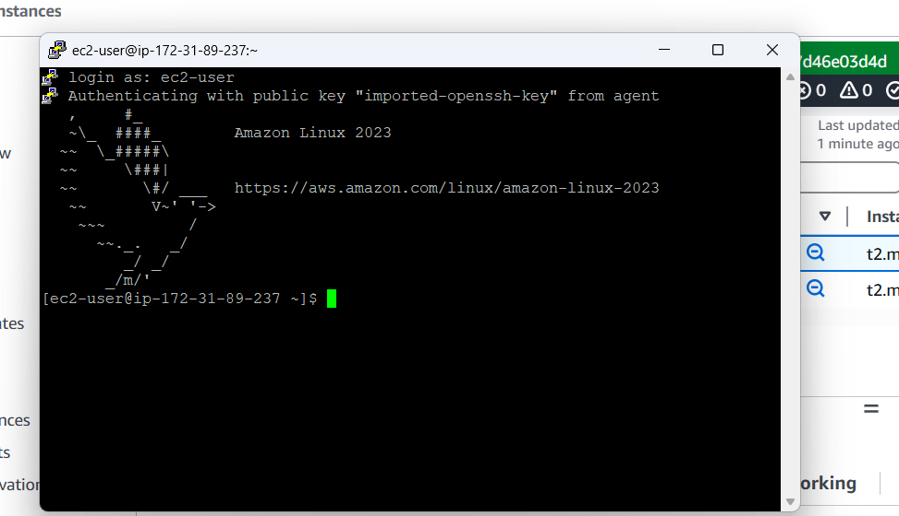

1. Change to switch user using sudo su -



To install Prometheus, go to opt directory using cd /opt



Visit the website : [Prometheus - Monitoring system & time series database](https://prometheus.io/)

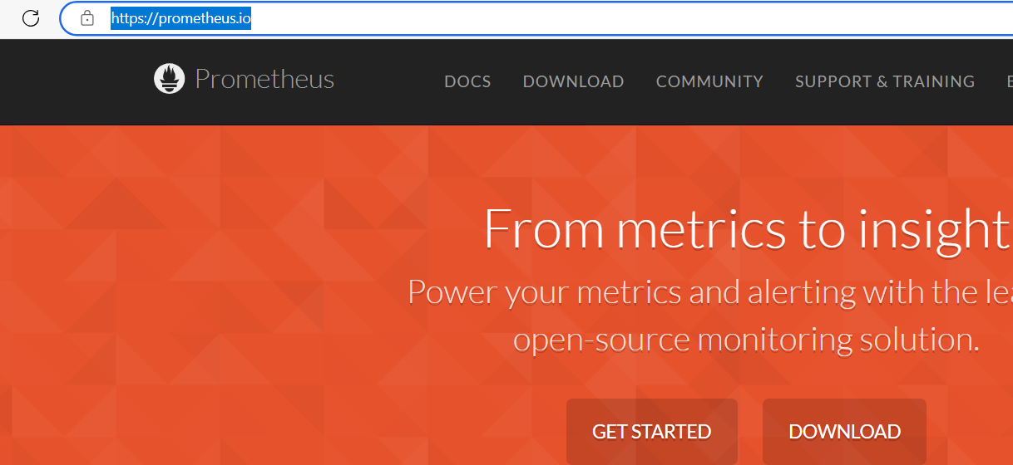

Goto download, and copy the link to download in linux machine and use

wget https://github.com/prometheus/prometheus/releases/download/v2.53.4/prometheus-2.53.4.linux-amd64.tar.gz

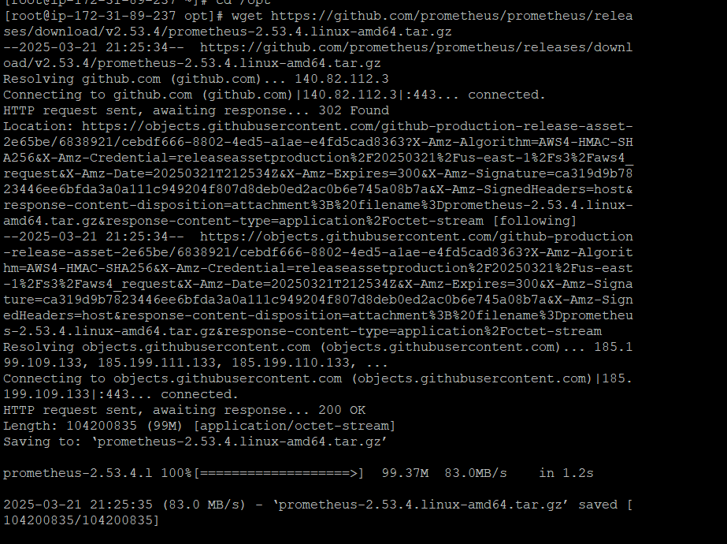

1. Since it is in tar format, extract the file using

tar -xvzf prometheus-2.53.4.linux-amd64.tar.gz

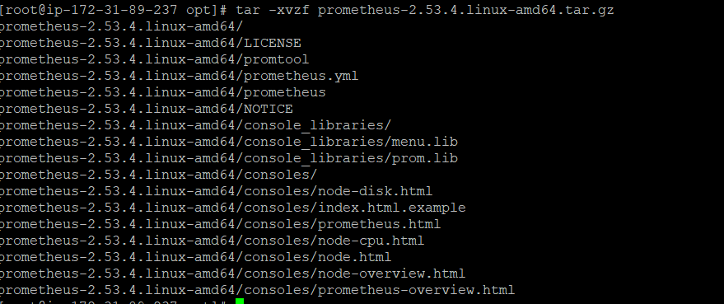

cd prometheus-2.53.4.linux-amd64

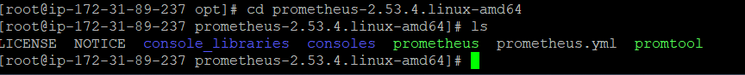

vi Prometheus.yml

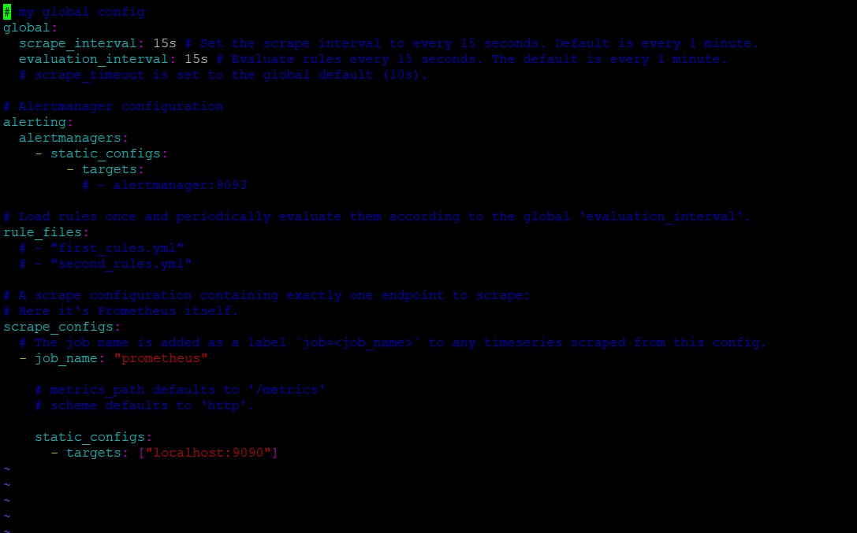

The local host is 9090.

1. Run the Prometheus

./prometheus --config.file=prometheus.yml & - & is used since it will run in background as well

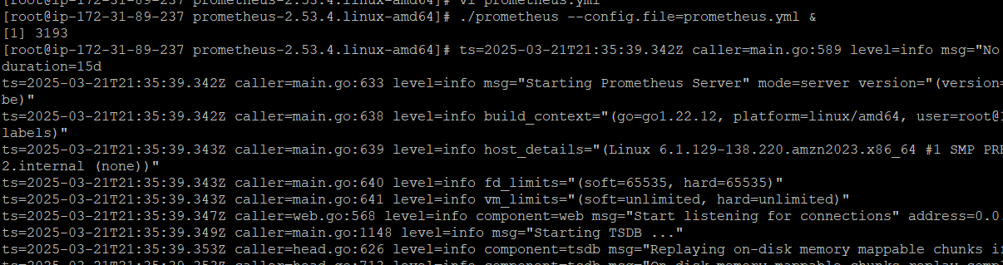

Copy the Prometheus public ip 44.212.44.52

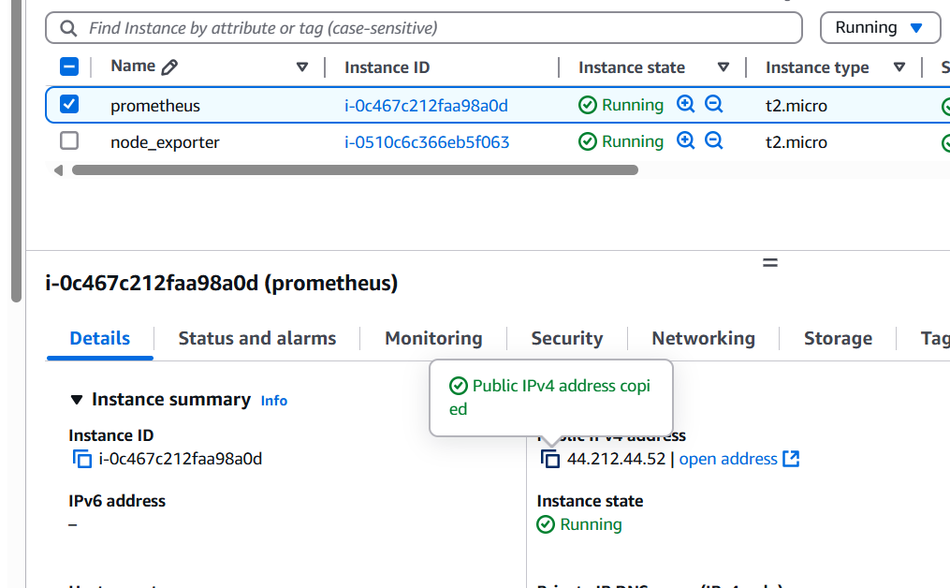

http:// 44.212.44.52:9090

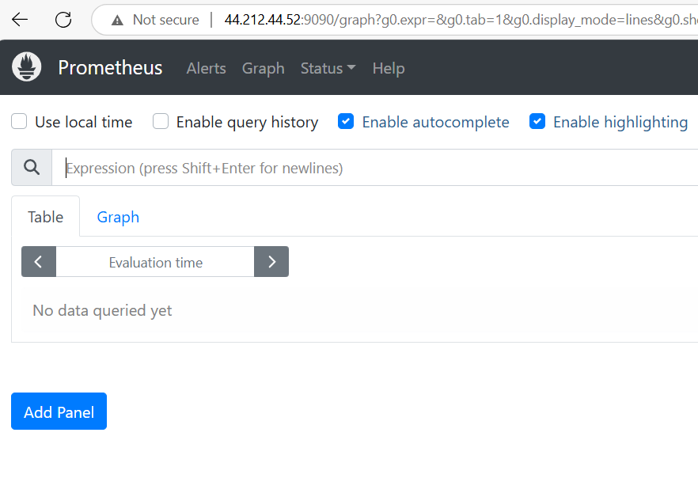

Use this process_cpu_seconds_total and press execute

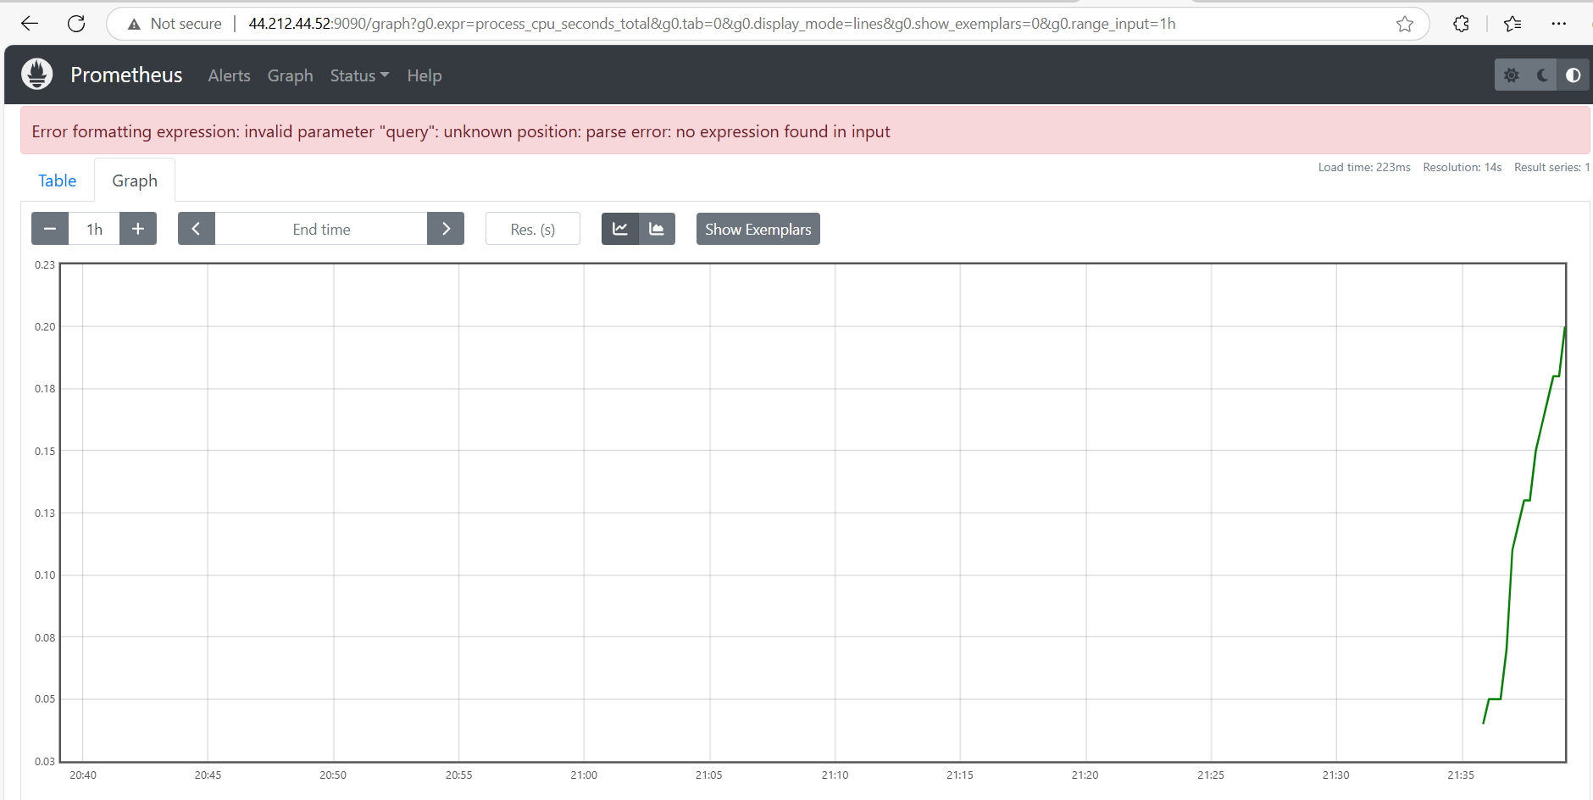

1. Connect the node_explorer instance and install node exporter in the same way.

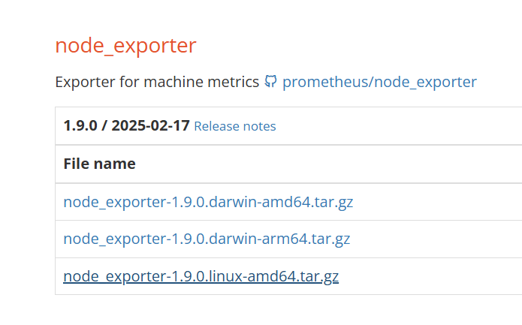

Copy the link use

Wget <https://github.com/prometheus/node_exporter/releases/download/v1.9.0/node_exporter-1.9.0.linux-amd64.tar.gz>

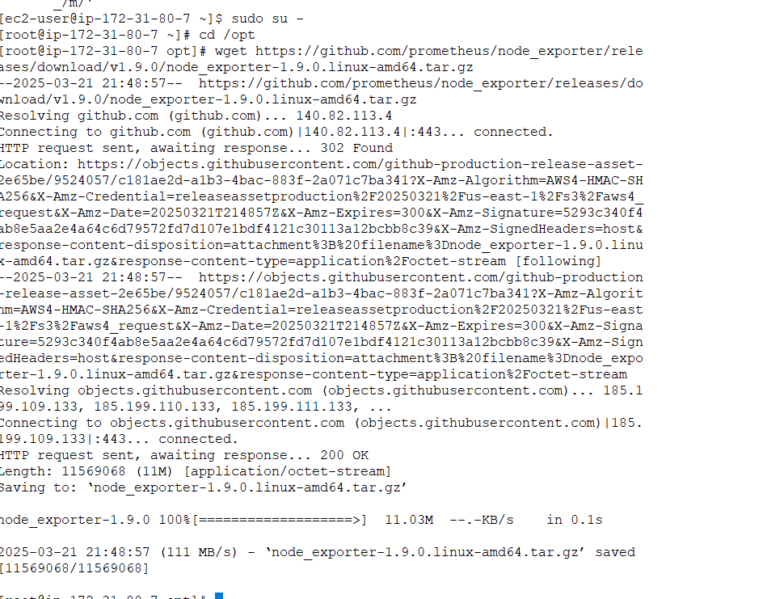

Extract using

tar -xvzf node_exporter-1.9.0.linux-amd64.tar.gz

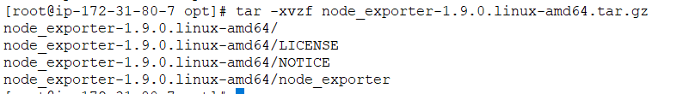

cd node_exporter-1.9.0.linux-amd64/node_exporter

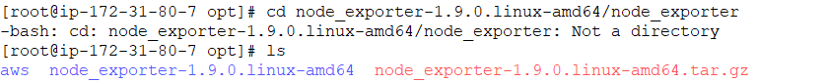

cd node_exporter-1.9.0.linux-amd64



Run using ./node_expoter &

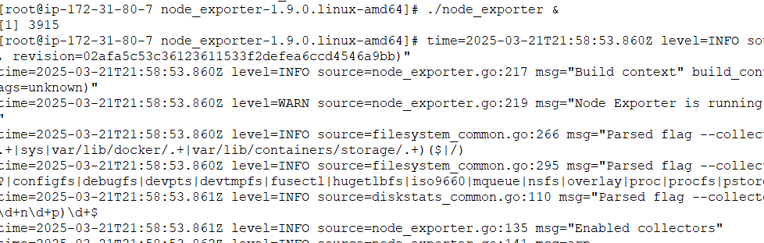

The port is 9100



Copy the node_exporter instance ip to check whether it is running

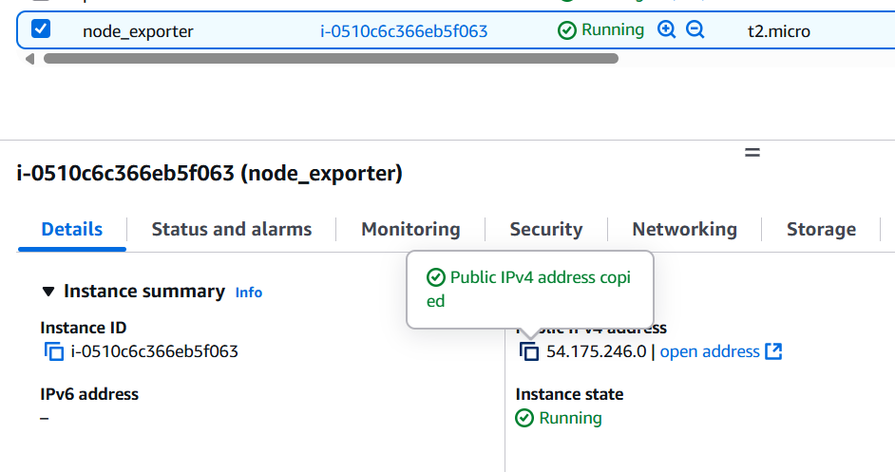

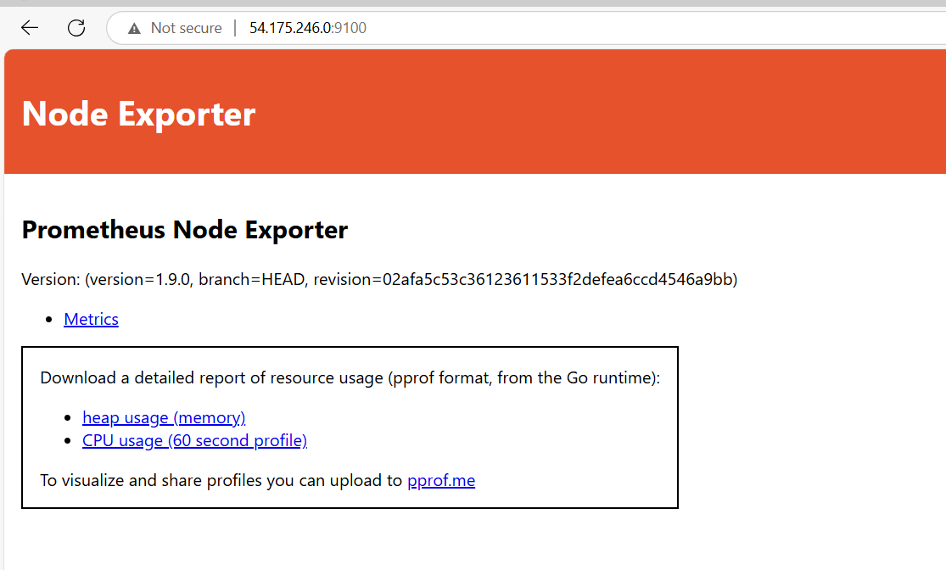

Now both promethus and node exporter is installed in both instances respectively. Now include this node exporter in promethus yaml file.

1. Add the job in Prometheus.yaml

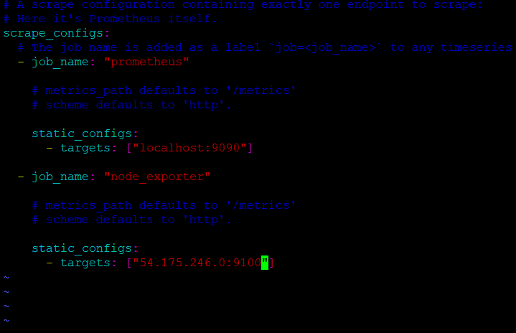

To restart use :

ps -ef | grep Prometheus



kill 3193

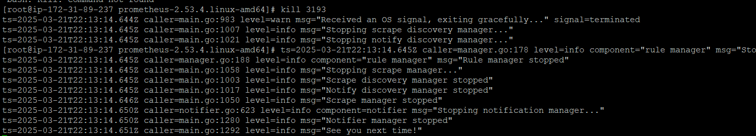

Then again run

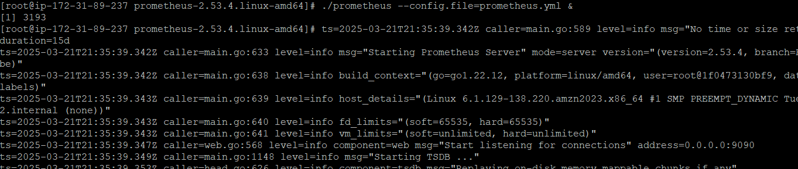

Now the job port_exporter is also added to Prometheus

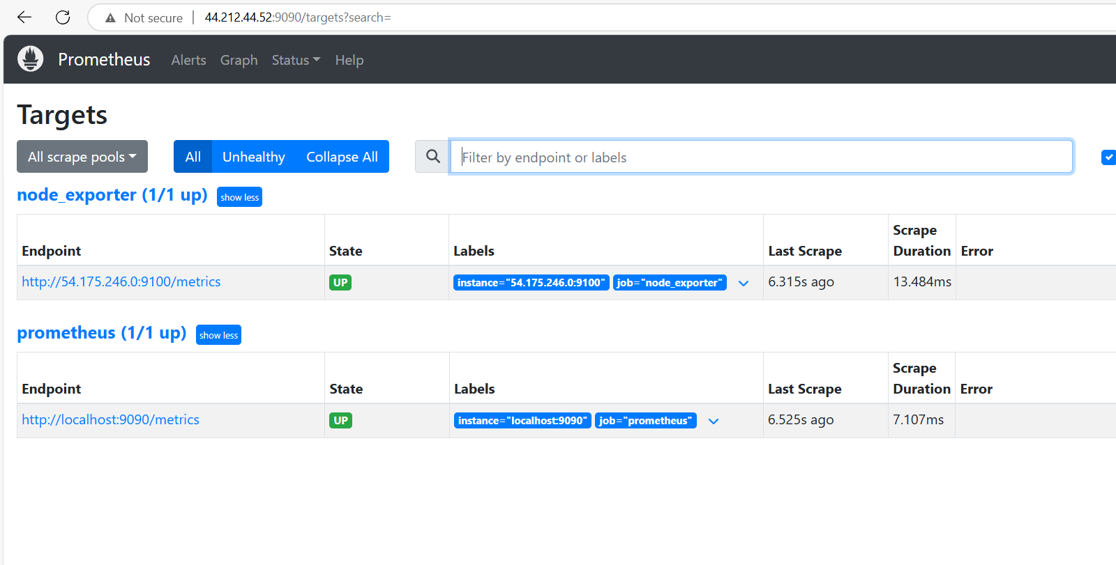

1. Now Prometheus is installed port_exporter is also installed and connected port_exporter in the Prometheus.

Finally, Grafana has to be installed in Prometheus instance for visualization to see metrics dashboard.

Navigate to cd /opt



Visit the website [Download Grafana | Grafana Labs](https://grafana.com/grafana/download) to get the Grafana download link

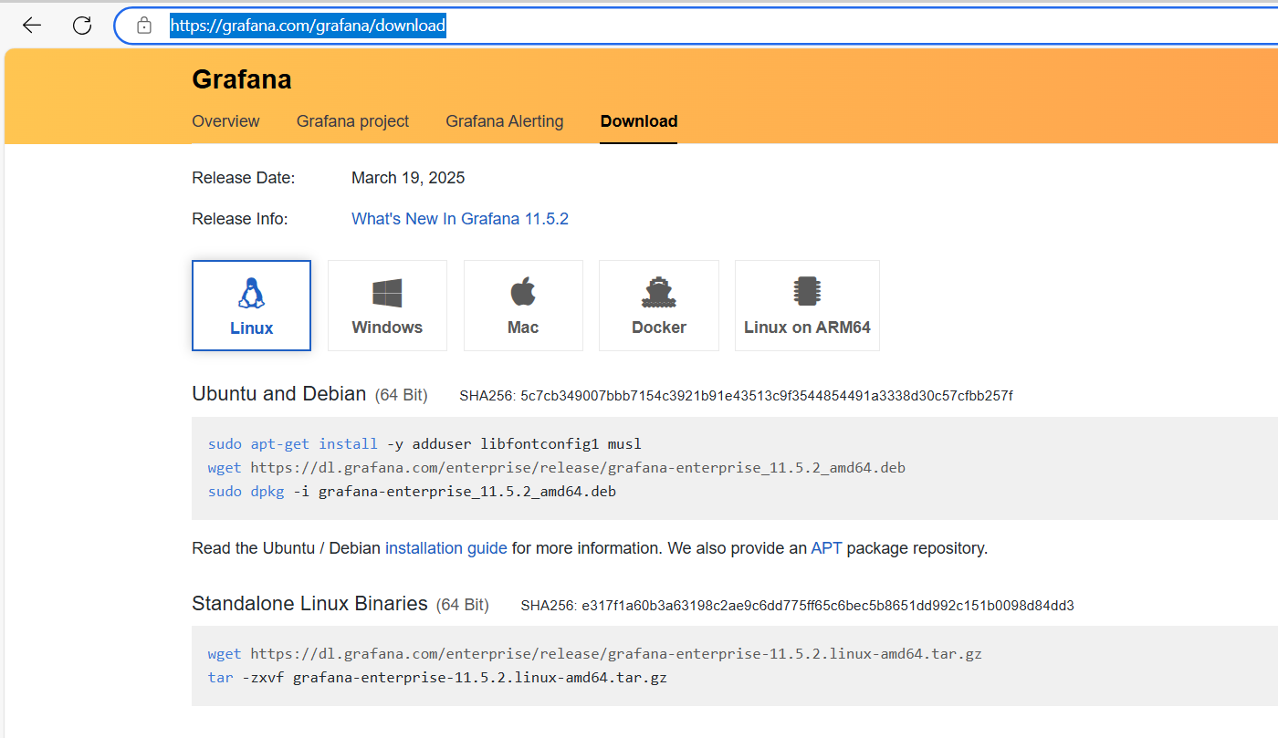

wget <https://dl.grafana.com/enterprise/release/grafana-enterprise-11.5.2.linux-amd64.tar.gz>

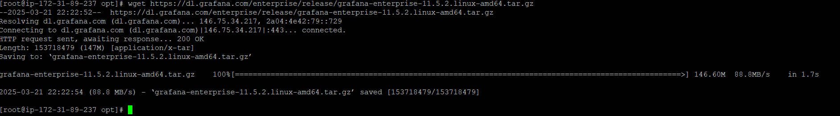

tar -zxvf grafana-enterprise-11.5.2.linux-amd64.tar.gz

cd grafana

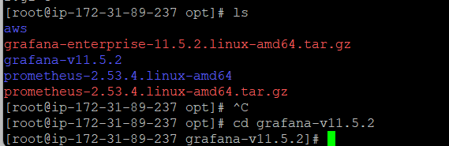

Cd bin

./grafana-server &

port:3000

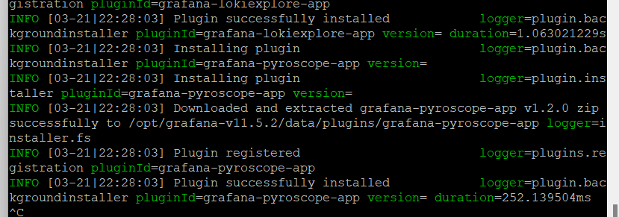

Copy the Prometheus public address

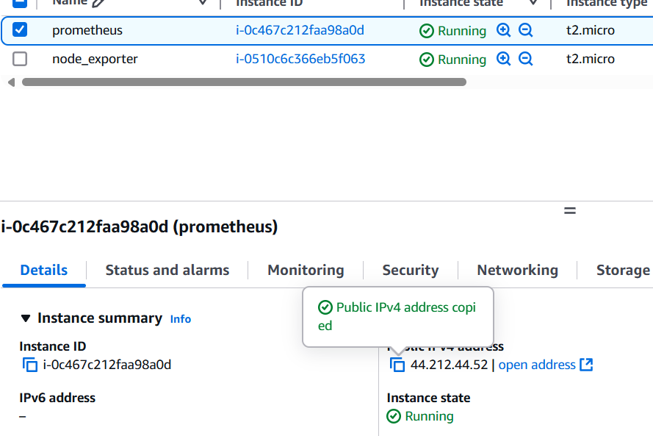

1. Grafana page is displayed

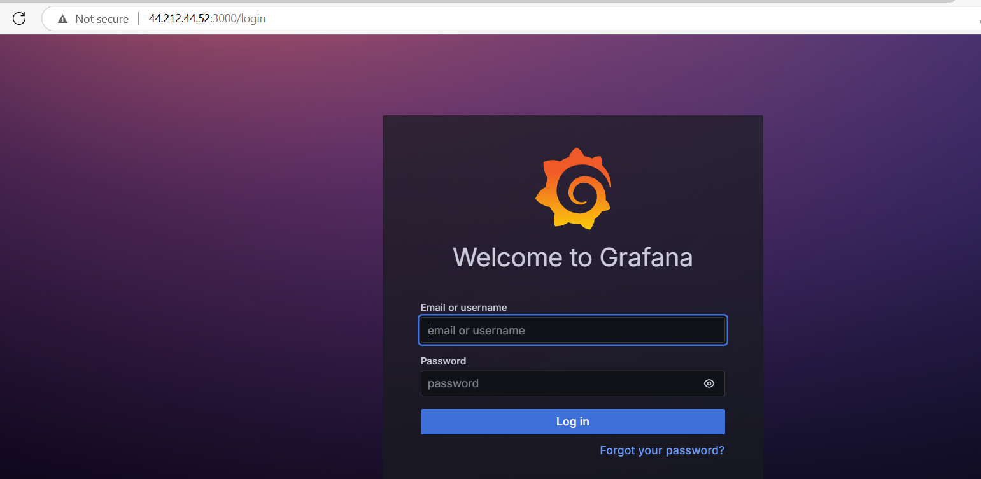

Login using credentials, use admin as the default password. Then change the pw.

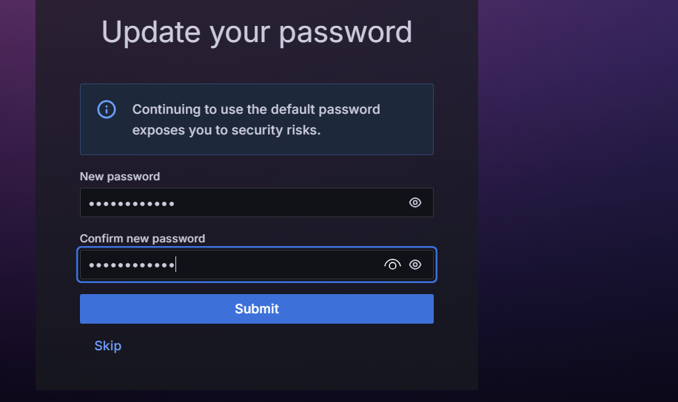

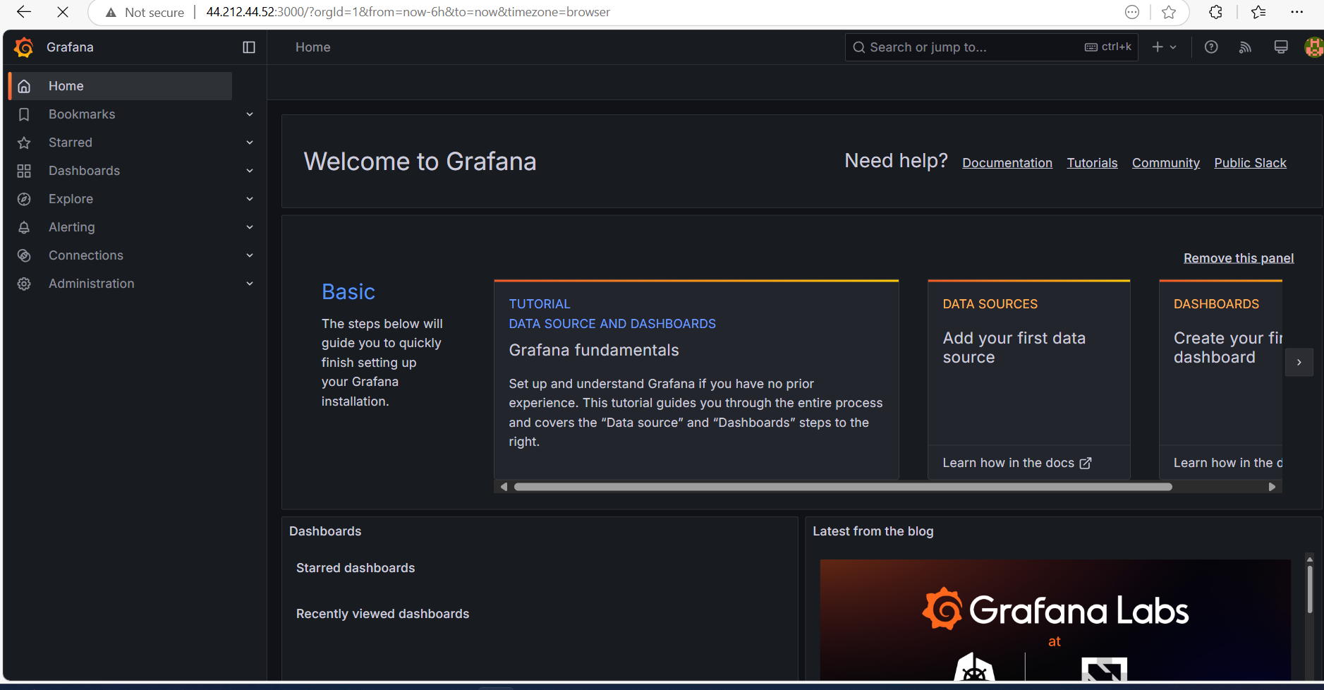

Add the data sources

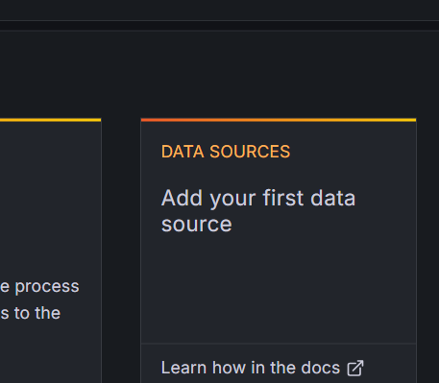

Choose Prometheus

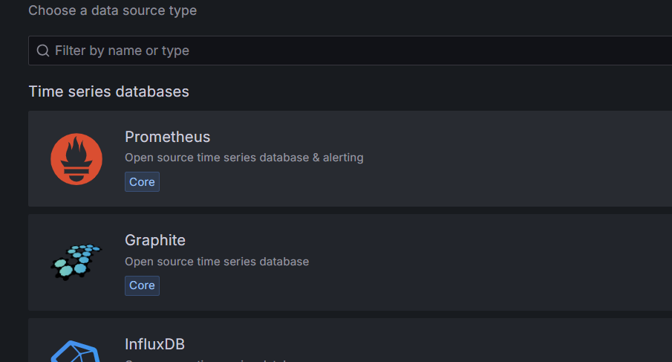

Give the Prometheus url

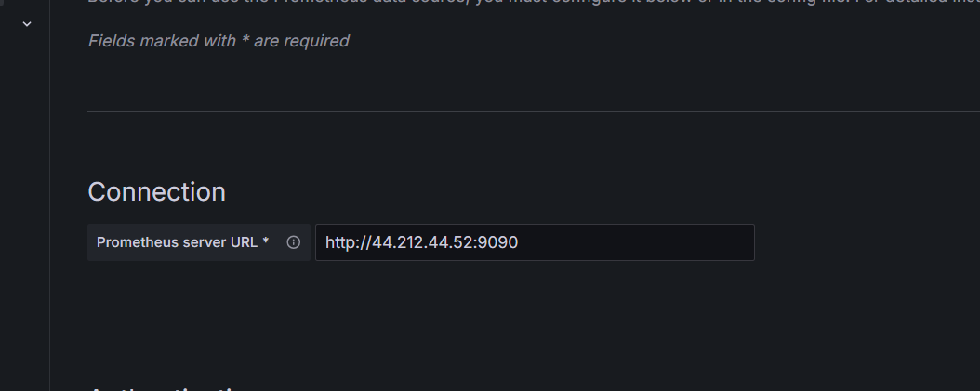

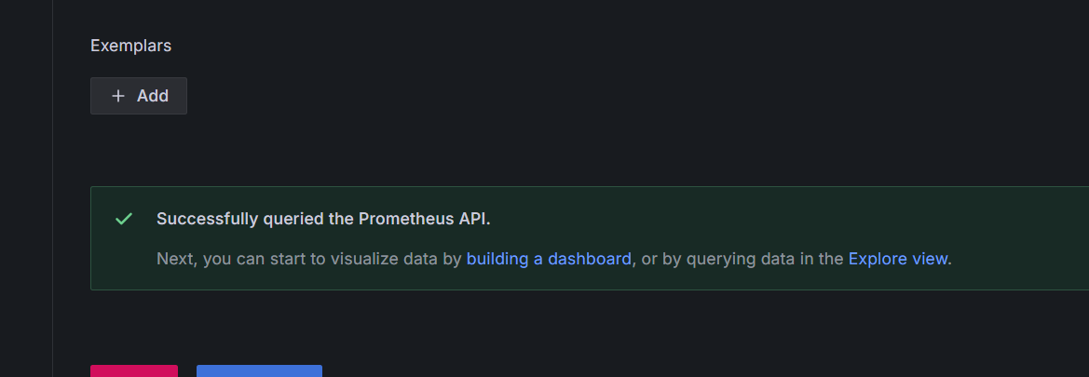

Then go to home> new dashboard

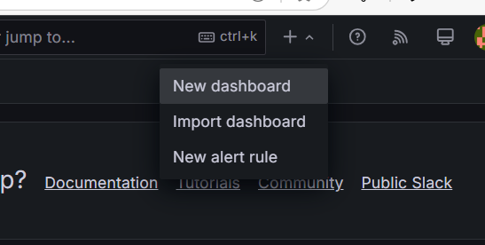

Add visualization

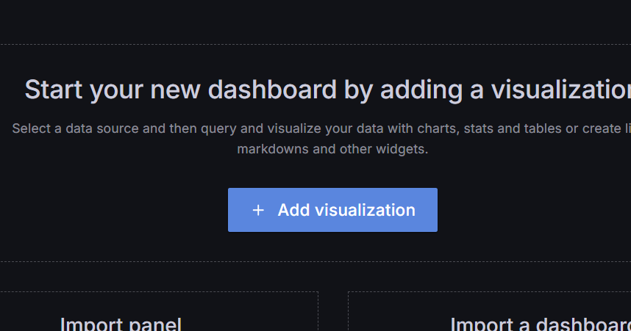

Select the metrics, label and value

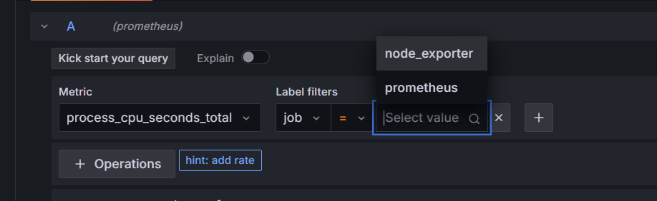

Now the graph is displayed

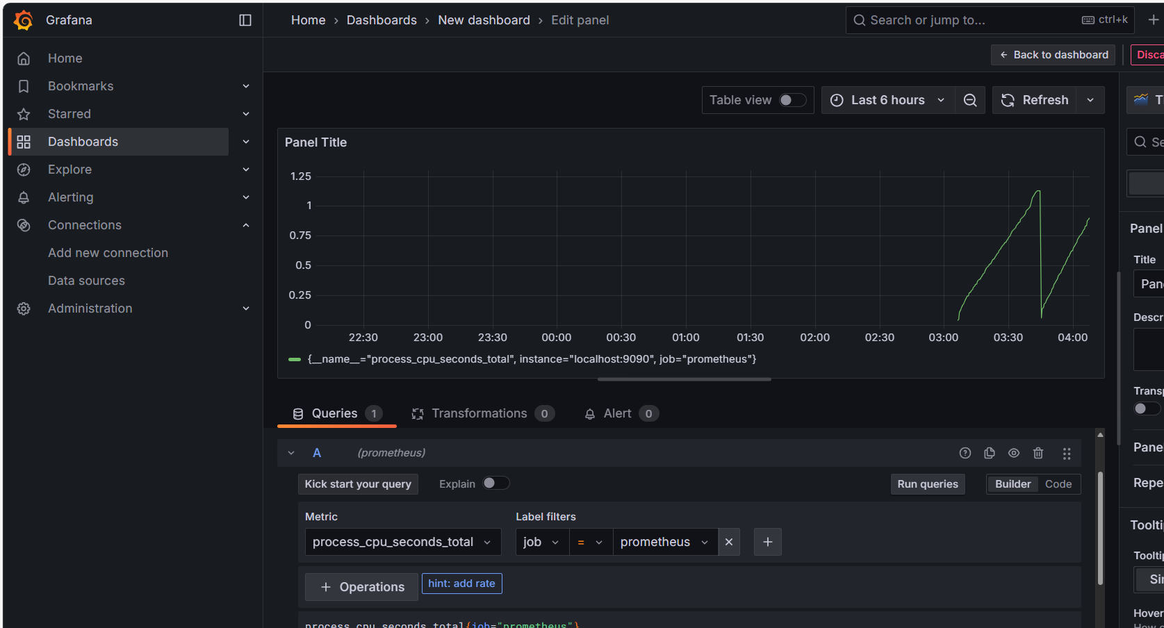

Explore different virtualization options

